**Name…………………………………………………Signature…………………**



**BUSIIKA MUSLIM SECONDARY SCHOOL**

**UGANDA CERTIFICATE OF LOWER SECONDARY EDUCATION**

**END OF TERM 2ASSESSMENT 2023**

PRINCIPLES AND PRACTICES OF AGRICULTURE

(THEORY )

**S.3**

**Paper 1**

**2HOURS**

**INSTRUCTIONS FOR THE CANDIDATE**

1.Answer all questions in section A and B

|  |  |  |  |
| --- | --- | --- | --- |
| **For Examiner’s Use Only** | | | |
| **Part** | **Question** | **Marks** | **Examiner’s Signature & No** |
| **A** | **No. 1-5** |  |  |
| **B** | **No.** |  |  |
| **No.** |  |  |
| **No.** |  |  |
| **No.** |  |  |
| **TOTAL** | |  |  |

**SECTION A**

1. The diagram below shows part of digestive system of a ruminant animal.

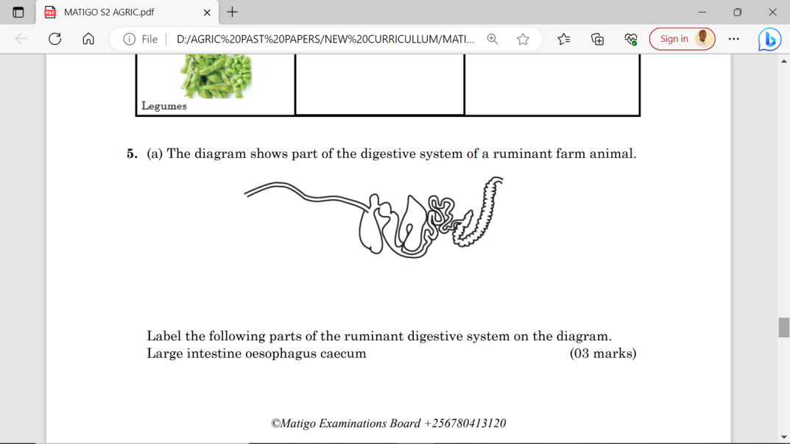

a)Label the following parts of the ruminant digestive system on the diagram. Large intestine ,oesophagus, caecum (03 marks)

………………………………………………………………………………………………………………………………………………………………………………………………………………………………………………………………………………………………………………………………

(b).Describe the role of each part in the digestive system:

Small intestine…………………………………………………………………………………………

…………………………………………………………………………………………(02 marks)

Large intestine……………………………………………………………………………………………

…………………………………………………………………………………………………(02 marks)

(c). Suggest how having rumen improves the process of digestion in farm animals.

…………………………………………………………………………………………………………………………………………………………………………………………………………………………………………………………………………………………………………………………………………………………………………………………………………………………………………………(03marks)

2(a) A student was testing a sample of soil. The sample of soil was mixed, shaken with water and allowed to settle in a measuring cylinder. The particles settle according to their size. The largest particles settle at the bottom. One of the diagrams, A to D, shows the correct result of this test.

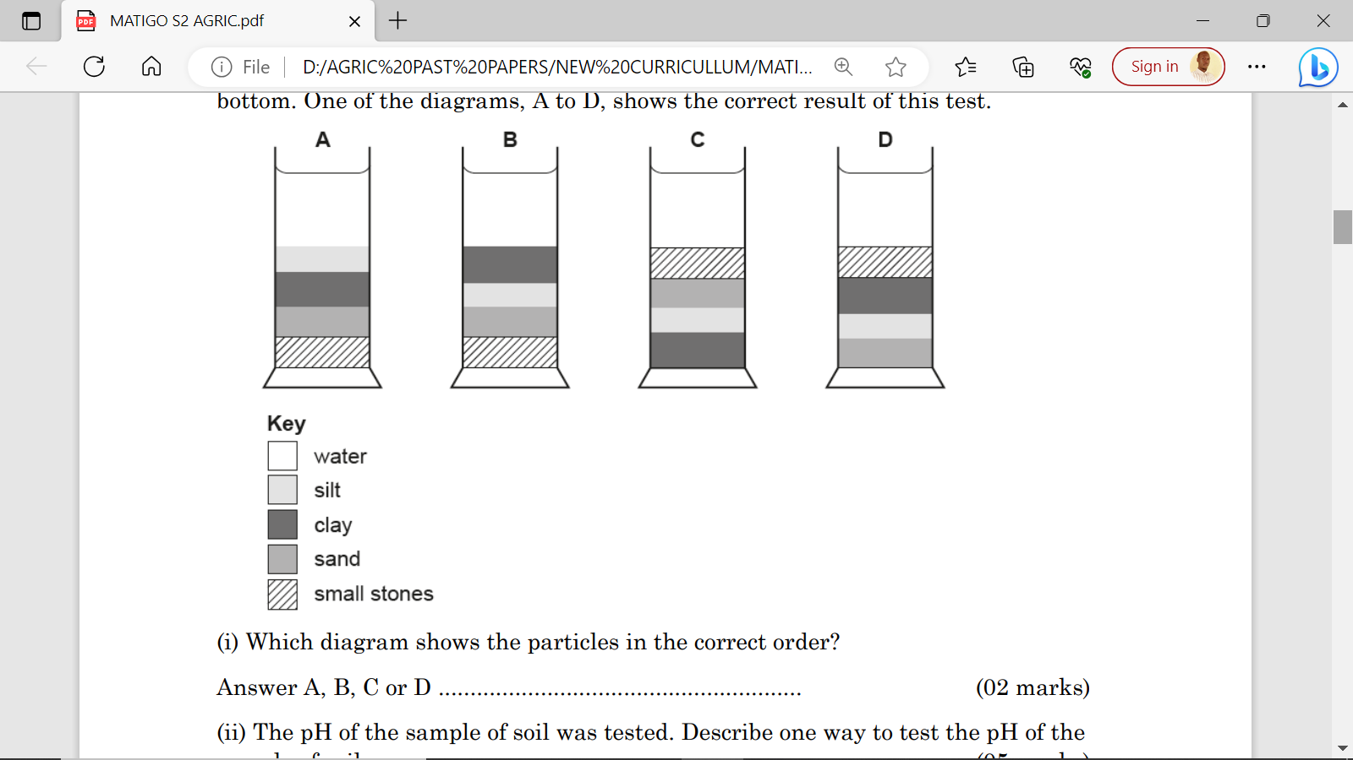

(i). Which diagram shows particles in correct order?

Answer A, B, C or D…………………………………………………………………………

(ii) Describe the practices that can be used to improve soil and crop growth.

(05 marks)

………………………………………………………………………………………………………………………………………………………………………………………………………………………………………………………………………………………………………………………………………………………………………………………………………………………………………………………………………………………………………………………………………………………………………………………………………………………………………………………………………………………………………………………………………………………

(iii) Suggest three materials required when improving soil and crop growth

(03 marks)

………………………………………………………………………………………………………………………………………………………………………………………………………………………………………………………………………………………………………………………

3a. As part of soil formation involves breaking down parent material such as rocks. Describe how parent rock is broken down by biological weathering.

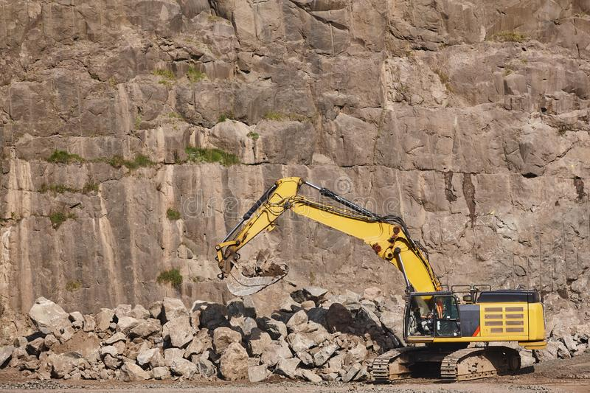

(04 marks)

………………………………………………………………………………………………………

……………………………………………………………………………………………………………………………………………………………………………………………………………… ……………………………………………………………………………………………………..

b). Suggest two farming practices that can result in soil becoming acidic.

(02 marks)

………………………………………………………………………………………………………………………………………………………………………………………………………………

c). Explain why Uganda need Agriculture as its “back bone”. (04 marks)

……………………………………………………………………………………………………………………………………………………………………………………………………………………………………………………………………………………………………………………………………………………………………………………………………………………………… 4. (a) The diagram shows three different positions A, to C, where a rake has been placed after being used.

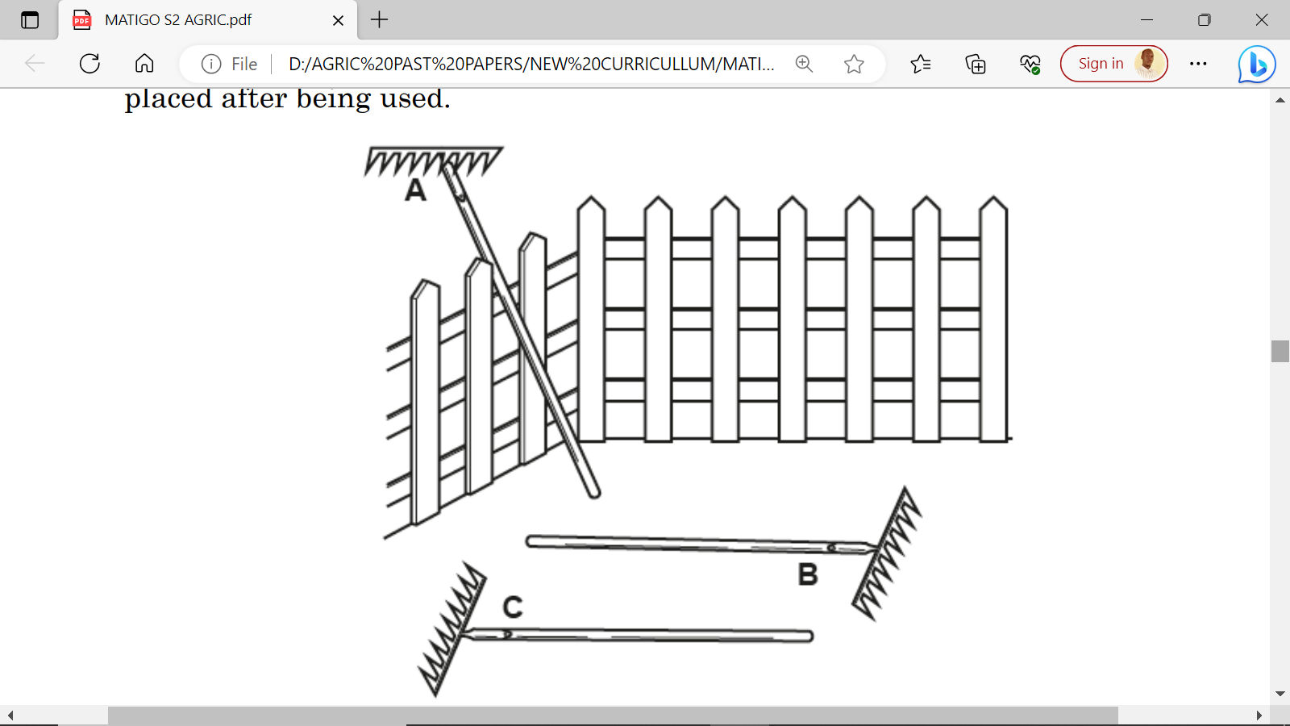

Use the letter A, B or C to identify a position. Suggest the possible accident that could occur as the result of leaving the rake in this position.

Rake position………………………………………………………………………(02 marks)

Accident……………………………………………………………………………(02 marks)

(b).(i) Describe one reason to use a rake for cultivation. Describe one to maintain a rake after use.

Reason……………………………………………………………………………………………

…………………………………………………………………………………………(01 mark)

Way to maintain……………………………………………………………………………......

…………………………………………………………………………………………………………………………………………………………………………………………….…(02 marks)

5. Vegetables are grouped as shown in the table below. Complete the table in blank columns. (10 marks)

|  |  |  |
| --- | --- | --- |
| **Group** | **Name of the Example** | **Other example in your community** |
| lLeafyC:\Users\XTACY\AppData\Local\Microsoft\Windows\INetCache\Content.Word\1689094596591.jpg | …………….. |  |
| FruitC:\Users\XTACY\AppData\Local\Microsoft\Windows\INetCache\Content.Word\1689094531449.jpg | ……………… |  |
| RootC:\Users\XTACY\AppData\Local\Microsoft\Windows\INetCache\Content.Word\1689095306821.jpg | …………….. |  |
| Bulb | …………….. |  |
| LegumeC:\Users\XTACY\AppData\Local\Microsoft\Windows\INetCache\Content.Word\1689094496830.jpg | …………… |  |

**SECTION B**

6.a) The pie chart below shows the relative proportions of the main components of soil. Choose words from the list to label the pie chart.

Mineral, Bedrock, Organic matter, Salt, Pore, Rock particles, Water, Air

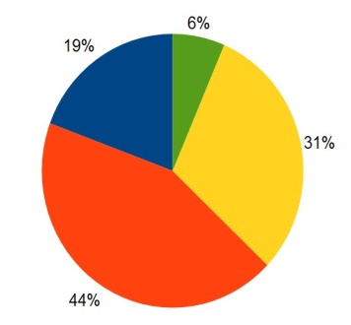

……………………………………………………………………………………………………………………………………………………………………………………………………………………………………………………………………………………………………………………… (**1 Mark**)

b) A sample of dry soil was passed through soil sieves. The results are shown below:

|  |  |  |
| --- | --- | --- |
| **Particle type** | **Mass/g** | **Percentage (%) mass** |
| Sand | 22.8 |  |
| Silt | 10.4 |  |
| Clay | 6.8 | 17 |
| **Total mass** |  |  |

1. Calculate the total mass of the dry soil sample. Show your working.

(**1 Mark**)

……………………………………………………………………………………………………………………………………………………………………………………………………………………………………………………………………………………………………………………………………………………………………………………………………………………………………………………………………………………………………………………………………………………………………………………………………………………………………………………………………………………………………………………………………………………… ………………………………………………………………………………………………………………………………………………………………………………………………………………

ii) Complete the table above to show the percentages of sand and silt as components of the sample. Show your working and reason for each step.

**(2 Marks**)

………………………………………………………………………………………………………………………………………………………………………………………………………………………………………………………………………………………………………………………

c) The percentage (%) organic matter is a useful measure of a soil’s quality. Suggest the key procedure you can use to measure the percentage (%) organic matter present in a fresh soil sample.**(2 Marks)**

………………………………………………………………………………………………………………………………………………………………………………………………………………………………………………………………………………………………………………………………………………………………………………………………………………………………

d) Beans, cow peas, groundnuts are nitrogen fixing plants. Owesi is a farmer in Kasese growing groundnuts. Which of the three types of fertilisers with explanation would you advise the farmer to use in groundnuts?

20:10:10 5:10:10 5:5:5

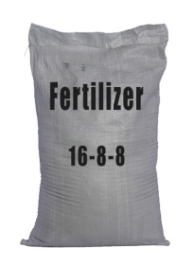 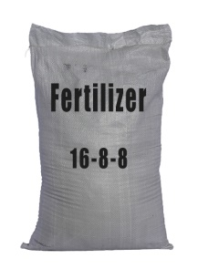 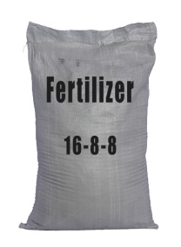

**(1 Mark)**

………………………………………………………………………………………………………

e) In what other one different way can this farmer achieve the same results?

**(1 Mark)**

………………………………………………………………………………………………………………………………………………………………………………………………………………………………………………………………………………………………………………………

7.(a) Complete the table on tools used to keep animals in a healthy state.

(20 marks)

|  |  |  |  |  |
| --- | --- | --- | --- | --- |
| **Tool** | **Name** | **Use** | **How it is used** | **When it is used** |
|  |  |  |  |  |
|  |  |  |  |  |
|  |  |  |  |  |
|  |  |  |  |  |
| C:\Users\XTACY\AppData\Local\Microsoft\Windows\INetCache\Content.Word\1689147823022.jpg |  |  |  |  |

8. Imagine you are a cattle farmer living in an area susceptible to East coast fever, Design a brochure you would use to educate farmers on how to control diseases to enable them easily market livestock and their products.

**(10 Marks)**

**\*\*\*\*END\*\*\*\***